Duplicate ICSR Detection Algorithm in EudraVigilance
Methodology currently in use
- Background information
The new algorithm is composed of two independent parts:
- the first part is characterised by
  - i) having all cases in EudraVigilance compared to each other;
  - ii) its simplicity: a matching on a key variable is sufficient to flag the pair as potential duplicate;
- the second part, instead, is characterised by
  - i) grouping records into different blocks based on the value of a sub-set of key variables and then only comparing cases within the same block;
  - ii) using a more-complex statistical method. The output of this second part is a value that represents the probability that a pair is a duplicate; pairs above a certain threshold are considered potential duplicates and are then manually assessed (this second part can assess only the pairs not identified as potential duplicates in the first part of the algorithm if this improves the time performance).
Figure 1 provide an overview of how the two parts are linked together and a possible solution of how they interface with the auto master algorithm that should be run at first (the best way to integrate the auto master algorithm in the algorithm described in this document is left to ICT).
- General request for ICT implementation
It is extremely important that the algorithm is implemented in a flexible way in order to be able to change some of its parts easily (i.e.: adding new variables for comparisons, changing the way variables are compared, …).
This is due to both changes that will affect the type and way of ICSRs reporting and to the learning process that is intrinsically associated with an algorithm that is tested on a daily based.
Figure 1. Overall process
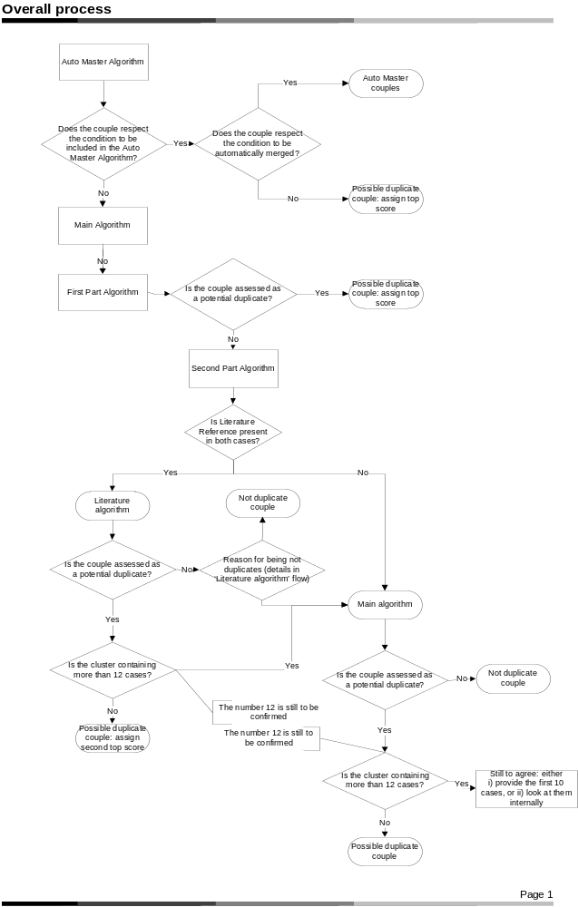
In particular, we foresee that the implementation of the new legislation with the receiving of non serious and non medically confirmed reports (an additional source of duplication) and the future implementation of the new ISO ICSR will have serious impacts on the performance of the current algorithm as described in this document leading to add new variables to compare and probably to different grouping criteria and to different way to compare the variables.
Moreover, ‘internal’ factors such as better data quality (thanks to Kinapse work streams) and the results of a comparison study of the main ICSRs duplicate detection algorithms used in Europe (thanks to a research project in the Protect consortium) might open new opportunities to improve the performance of the current algorithm.
Last but not least, weights will need to be updated every six / twelve months.
- Cleaning of the variables, creation of aggregate variables and rarity weights
For all the free text variables used in the algorithm a considerable amount of data cleaning has been undertaken in order to take into account possible misspellings and to avoid meaningless matches (for instance, avoiding scoring a full match when comparing two records with the patient initials ‘Unknown’).
The cleaning has been undertaken through the use of regular expressions and for some variables (i.e. Duplicate Field, Literature Reference and Patient Initial) has been quite extensive.
The approach used by DCM has been to create beforehand new datasets with the original variables, the cleaned version of the original variables and useful aggregate information (for instance the scientific group high level or the patient age) for all the variables used by the algorithm. Moreover, for the variables that are compared using the method called ‘Rarity weight’ (discussed later), this weight has been included as well. This way to proceed avoids that the information is created dynamically millions of time during the comparisons allowing a considerable amount of time.
- Brief description of the first part
As mentioned above, the first part of the new duplicate detection algorithm compares all the cases in EudraVigilance with each other on selected fields (see table 1). A match in any of these fields results in the assessed pair being highlighted as potential duplicate.
- Fields where a match determines a potential duplicate
Field | E2B(R2) code
Duplicate Number | A.1.11.2
Worldwide Case Number | A.1.10
Safety Report Unique Identifiers | A.1.0.1

This part, even if looking similar to the auto master algorithm, need to be kept separated from it for the following reasons:
- The duplicates number (A.1.11.2) can not be included in the auto master. The rationale is that the duplicate number is populated when a case was not transmitted electronically, meaning that the receiver will have manually entered the case into their database. Therefore, it is very unlikely to yield cases which can be used in auto-master generation, because they will be subtly different in crucial ways;
Figure 2. First part of the algorithm
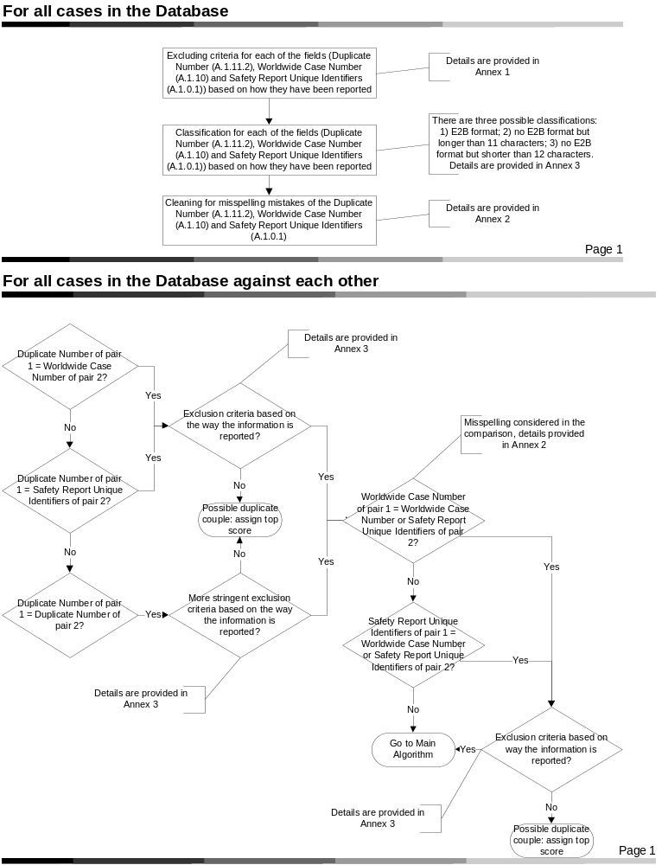
- The comparison of the Safety Report ID (A.1.0.1) and the WW case safety ID (A.1.10) allowing for misspelling (e.g.: 1 = i) can not be included in the auto-master creation. The auto-master is intended for cases where a case was transmitted electronically to various receivers and then re-transmitted electronically. The case numbers shouldn't be changed manually and so there will be no need to allow for misspellings or copying errors;
- The type of comparisons are different: the auto-master can not afford any false positive therefore contains checks on additional fields (I.e.: sender, …); on the contrary, the first part of the algorithm give more importance to the sensitivity, therefore it tries to increase the number of useful matches through an extensive cleaning process and different type of exclusion criteria.
In conclusion, the first part of the main algorithm and the auto master are remarkably different; therefore the auto master can not replace the first part of the main algorithm.
- Brief description of the second part
The second part of the algorithm is more computationally intensive since it compares many more fields and it uses a statistical approach. For this reason, and due to the large amount of cases present in EudraVigilance (more than 3.1 millions), records are grouped into different blocks and compared with each other only within the same block. Table 2 shows the key variables used for the grouping.
- Grouping criteria
Field | E2B(R2) code | Comments
Patient Sex | B.1.5
Primary Source Country | A.1.1
Patient Age (+/- 5 years) | B.1.2.2a & b OR (B.2.i.4b and B.1.2.1b) | Calculated from Patient onset age or from Reaction Start Date and Patient Birth Date  Used only for Primary source countries with many cases (full list to be discussed)
Literature* | A.2.2 | Presence of a literature reference
Another complementary approach useful in order to reduce the number of possible comparisons is to exclude from the comparisons all the cases that do not carry enough information to allow for any match at the selected thresholds (i.e.: the cases with too many missing information). DCM is currently working on establishing a way to identify all the cases that do not contain enough information to be reliably matched, updates will be provided if the number of excluded cases is big enough to make any computational difference.
All the fields compared in the second part of the algorithm are shown in table 3. Some of the variables were not statistically significant when tested on the training data set (~67,000 assessed pairs of which ~40,000 confirmed duplicates): these variables are shown only for information, they will not be used in the final algorithm.
Instead some other variables are under investigation, they are shown in order to be taken into account during ICT planning of the implementation.

Figure 3. Introduction to the second part of the algorithm
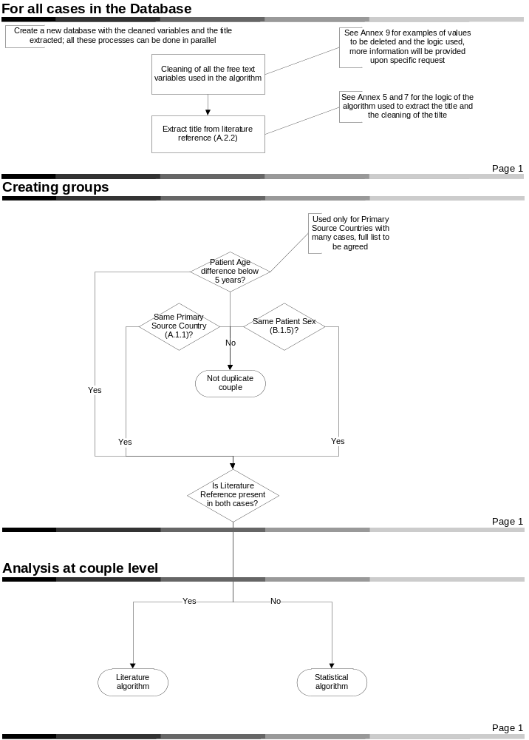
- Fields assessed by the second part of the algorithm
Section | Field | E2B(R2) code | Comments | Type of Weight | Type of comparison
Main | Occurrence Country | A.1.2 |  | Rarity | Simple
Main | Patient Initials | B.1.1 |  | Simple | Simple (allowing for inverse)
Main | Investigation Number | B.1.1.1d |  | Simple | Simple
Main | Patient Birth Date | B.1.2.1b |  | Simple | Date
Main | Patient Onset Age | B.1.2.2a & b |  | Simple | Date
Main | Seriousness Criteria | A.1.5.1 & A.1.5.2 | Non-significant in version 1, currently under investigation | Rarity | Simple
Literature | Literature Reference | A.2.2 | String comparison | Simple | String
Primary source | Eudra CT | A.2.3 & A.2.3.1 | Currently under investigation | Rarity | Simple
Primary source | Reporter Family Name | A.2.1.1d | Non-significant
Primary source | Reporter Postal Code | A.2.1.2f | Non-significant
Primary source | Reporter Country | A.2.1.3 | Non-significant
Reaction | Reaction Start Date | B.2.i.4b | B.2.i.4b | Simple | Date
Reaction | Reaction Term MedDRA PT | B.2.i.2.b | B.2.i.2.b | Rarity | Multiple
Reaction | Reaction Term MedDRA HLGT |  |  | Rarity | Multiple
Reaction | Reaction Term MedDRA SOC |  |  | Rarity | Multiple
Reaction | Reaction Outcome | B.2.i.8 | Non-significant
Drug | Recoded medicinal product | B.4.k.2.1 and B.4.k.2.2 | Recoded scientific composition high level is compared | Rarity | Multiple

- Weights
This part of the algorithm uses a statistical approach where weights are determined in two steps:
- For each field, a weight for a mismatch, a blank and a match has been calculated using the hit-miss model (as implemented by Norén et al. and described by Copas and Hilton), log-likelihood ratio and logistic regression.
When two cases are compared for a specific variable, three scenarios can appear:
  - Both cases are populated and the value of the variables is different: in this case the mismatch weight is applied. The mismatch weight is always negative;
  - At least one case is not populated: in this case the blank weight is applied. The blank weight is always equal to zero;
  - Both cases are populated and the value of the variables is the same: in this case the match weight is applied. The match weight is always positive and can be unique or changing according to the value of the match; the latter is called ‘Rarity weight’.
Rarity weight: for fields with a limited and fixed number of values, a match on a common term will have a lower weight than a match on a rare value (i.e.: a match on a common drug such as Paracetamol provides less information than a match on a rare drug reported only 10 times in the entire EV). The variables with type of weight ‘Rarity’ in table 3 have this property;
- Across fields, a multiple logistic regression has been performed to estimate the weight of each of the field and its statistical significance. This allows having an idea of the importance of each field in discriminating duplicates from non duplicates taking into consideration correlated fields.
The weights will be provided by DCM (no computation from ICT point of view) and updated every 6-12 months. This means that:
        - they needs to be implemented in flexible way;
        - the algorithm is faster since it does not need to calculate them dynamically.
- Type of comparisons
As a general rule, all the comparisons are case and space insensitive.
There are four different type of comparisons:
        - Simple: it’s just a yes/no comparison, when two fields are the same they are considered matches, when they are different they are considered mismatches;
        - String: takes into account possible misspelling during the comparison. It will provide a similarity value, where values above a certain threshold will be considered matches (and will take the match weight based on how much they are similar) and below will be considered mismatches;
        - Dates: takes into account how to deal with incomplete date formats and how distant are two dates. Dates not further than one year are considered matches (and will take the match weight according to how close they are following a logistic function / range), dates further than one year are considered mismatches;
        - Multiple: data are pre-processed initially to allow an easier comparison for multiple fields. This comparison allows to take into consideration the amount of information used in the comparison: for instance, if two safety reports have 5 drugs each and all the drugs are common between them there will be rewarded more compared to two safety reports with only one drug each and the drug is common (see example below).
Example of the multiple comparisons:
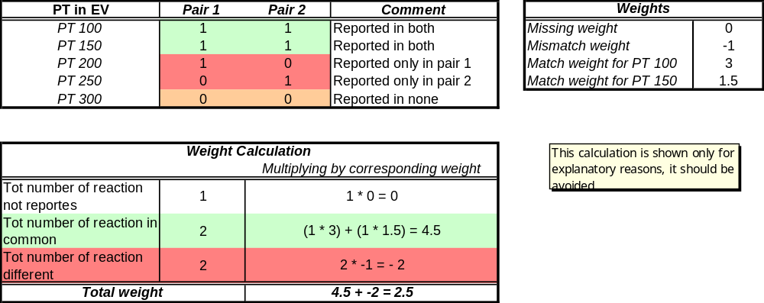
Figure 4. Literature algorithm
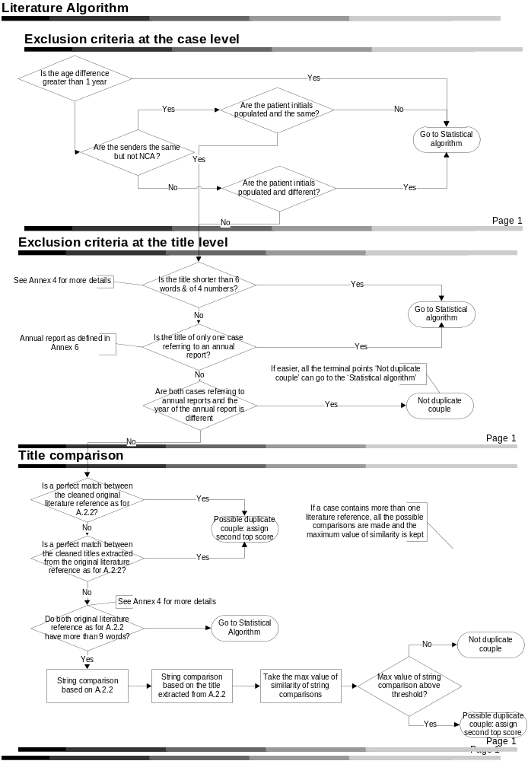
Figure 5. Statistical algorithm
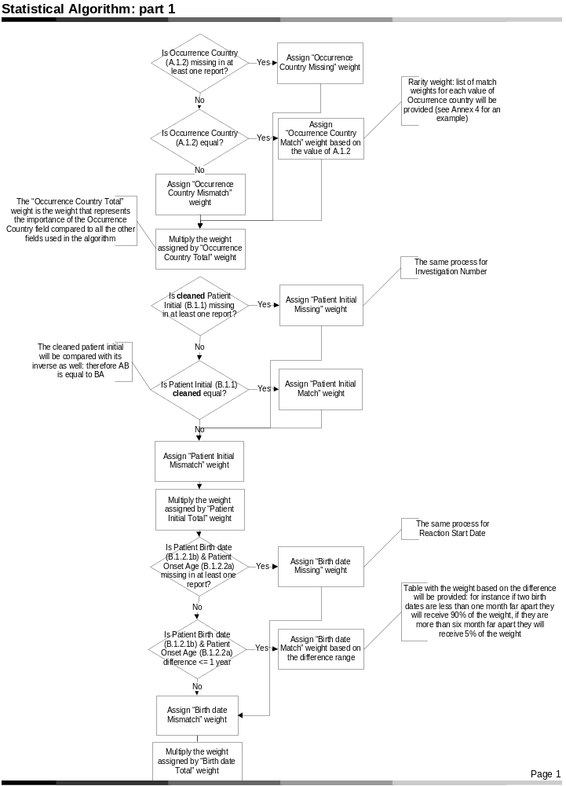
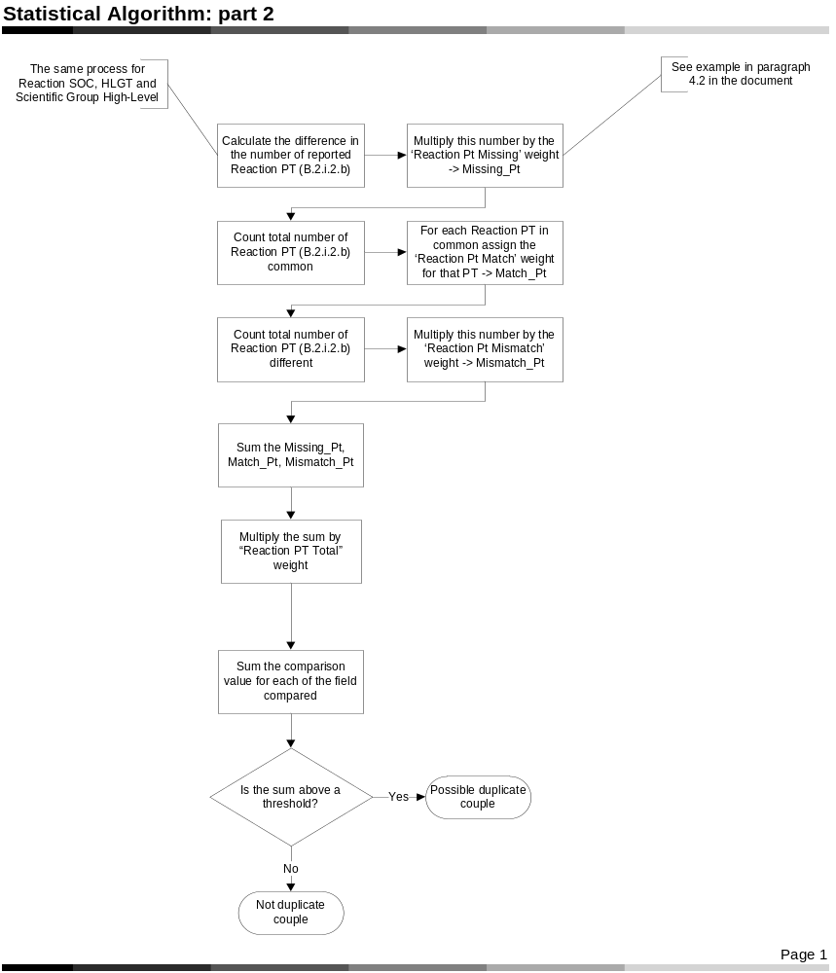
- Limitations
It is recommended to implement a check on the size of the cluster of the potential duplicate: clusters above a certain size should be dealt separately (to be discusses)
In this version of the document, some more clarifications have been provided in figure 1; however much more discussions and testing are necessary. In the worst case scenario that progress are not made on this aspects, ICT should still consider to have a check on the cluster size and to deal with the clusters above a certain size separately.
- Future updates
Besides major changes due to change in legislation (see paragraph 2), every 6 or 12 months (usually when updating the weights) the following updates might need to be considered:
- New variables to include: according to the development of a work package in Protect, some new variables might be considered. If these variables results significant in discriminating duplicates and if the improvement in the sensitivity and precision of the algorithm is considerable, they will need to be included;
- Drug section: when the recoding of all the terms is concluded, the comparison of the medicinal product will be investigated;
- Dates: since a misspelling might mean that dates far apart of 10 years are the same, I’m looking at a way to include a random component in the date comparison.
- Annex 1: Example of exclusion criteria for Duplicate Number, Worldwide Case Number and Safety Report Unique Identifiers
For Duplicate Number, Worldwide Case Number and Safety Report Unique Identifiers cases are excluded if one of the following is respected:
- length is <= 6;
For Duplicate Number, cases are excluded for the comparisons if one of the following is respected:
- no digit is present in the field;
- the word ‘literature’ or ‘article’ is present
reg_lit = prxparse ("/literature|article/i");
- the word ‘ link’ or ‘link ’ or only the word ‘link’ is present
reg_link = prxparse ("/ link|link |^link$/i");

- Annex 2: Example of cleaning for Duplicate Number, Worldwide Case Number and Safety Report Unique Identifiers
1) For the Duplicate Number the following cleaning has been done first:
dupl_cl = tranwrd(dupl_cl, 'gb-gb-a-mhra (former medicines control agency)-', '');
This means that 'gb-gb-a-mhra (former medicines control agency)-‘ is changed into ‘’
dupl_cl = tranwrd(dupl_cl, 'de-d-a-bfarm web-published icsrs (should not be e-reported)', 'de-bfarm');
dupl_cl = tranwrd(dupl_cl, 'it-it-a-italian medicine agency (aifa or nat. pharmacovig. net)-', 'aifa');
dupl_cl = tranwrd(dupl_cl, 'regulatory health authority united kingdom', 'mhra');
dupl_cl = tranwrd(dupl_cl, 'regulatory health authority upsa (do not use)', 'afssaps');
dupl_cl = tranwrd(dupl_cl, 'regulatory health authority france', 'afssaps');
dupl_cl = tranwrd(dupl_cl, 'regulatory health authority austria', 'basgages');
dupl_cl = tranwrd(dupl_cl, 'ca-regulatory health authority canada-', '');
dupl_cl = tranwrd(dupl_cl, 'regulatory health authority denmark', 'dkma');
dupl_cl = tranwrd(dupl_cl, 'regulatory health authority ireland', 'imb');
dupl_cl = tranwrd(dupl_cl, 'regulatory health authority italy', 'minisal02');
dupl_cl = tranwrd(dupl_cl, 'regulatory health authority norway', 'nomaadvre');
dupl_cl = tranwrd(dupl_cl, 'regulatory health authority portuga', 'infarmed');
dupl_cl = tranwrd(dupl_cl, 'regulatory health authority romania', 'nma');
dupl_cl = tranwrd(dupl_cl, 'regulatory health authority spain', 'agemed');
dupl_cl = tranwrd(dupl_cl, 'regulatory health authority sweden', 'mpa');

2) For the three fields (Duplicate Number, Worldwide Case Number and Safety Report Unique Identifiers) all the following ‘special characters’ have been removed:
- ! “ # $ % & ‘ ( ) * + , . / : ; < = > ? @ [ \ ] ^ - _ ` { | } ~
3) For the three fields (Duplicate Number, Worldwide Case Number and Safety Report Unique Identifiers), the following misspelling has been considered:
- 1 is considered a misspelling of i or l
- 0 is considered a misspelling of o
dupl_cl = translate(dupl_clean,'110','ilo');

4) Only for the Worldwide Case Number and Safety Report Unique Identifiers, when comparing between and across them, the following misspelling has been considered:
- 8 is considered a misspelling of b
- 5 is considered a misspelling of s
Case_fcl = translate(Case_cl,'58','sb');
- Annex 3: Example of excluding Duplicate Number, Worldwide Case Number and Safety Report Unique Identifiers
Classification¹ | Duplicate Number matches (WWID or Safety ID) | Duplicate Number matches Duplicate Number | (WWID or Safety ID) matches (WWID or Safety ID)
1) E2B format² | Potential Duplicates | Potential Duplicates if Primary Source country and Sex match | Potential Duplicates
2) No E2B and length >= 12 | Potential Duplicates | No assessment about possible duplicates | Potential Duplicates
3) No E2B and length <= 11 | Potential Duplicates if Primary Source country and Sex match or are missing | No assessment about possible duplicates | Potential Duplicates if Primary Source country and Sex match or are missing
1) If pair 1 belongs to a different classification compared to pair2, the more stringent criteria is applied to the couple ‘pair 1 – pair 2’. For instance, if pair 1 belongs to classification 2 and pair 2 belongs to classification 3, to the couple ‘pair 1 – pair 2’ classification 3 is applied.
2) The E2B format has been considered as follow:
- First two letters need to be a country code
- Followed by either _ or –
- Followed by at least a letter or a number
- Followed by either _ or –
- Followed by at least a letter or a number
reg_e2b = prxparse ("/^(&all_codes)(_|-)(\d|\D)+(_|-)(\d|\D)+/i");
- Annex 4: classify the title according to its length
According to the number of words the literature reference is classified in three categories:
a) when the title is too short it is not compared;
b) when the title is a middle length, it will be compared but only a perfect match is needed;
c) when the title is long a string comparison will be used.
In particular, if there are less than 6 words (where a word is considered to have at least one letter) and less than 4 numbers (string with only numbers) then the title is not extracted and the couple is assessed in the main algorithm.
Else if there are less than 9 words, the title goes in the category of the perfect match (it’s a simple yes/no comparison, when two fields are the same they are considered matches, when they are different, they are considered mismatches); finally, if the title is more or equal than 9 words the title will be compared with a string comparison.
*** Check whether the original title is long enough ***;
real_word = 0; numb = 0; real_numb = 0;
nwords_orig = countw(litref, ' ! $ % & ( ) * + , - . / ; < ^ | :');
do i = 1 to nwords_orig;
call scan (litref, i, pos, len,' ! $ % & ( ) * + , - . / ; < ^ | :'); *** return position and length of the i-th word ***;
put 'The value of pos is: ' pos;
put 'The value of small_len is: ' len;
if anyalpha(substr(litref, pos, len)) > 0 & len > 1 then real_word + 1;
if anyalpha(substr(litref, pos, len)) = 0 then numb + 1;
else do;
if numb > real_numb then real_numb = numb;
numb = 0;
end;
end;
if numb > real_numb then real_numb = numb;
short_tl = 'Perfect comp';
if real_word = 0 or (real_word > 0 & real_word <= 5 & real_numb < 4) then short_tl = 'Excl';
if real_word > 8 then short_tl = 'Norm comp';
- Annex 5: code to extract the title
Logic followed in extracting the title from the literature reference (the code is attached in Annex 8 for your reference; if trying to match the code, please note that the logic explained is a simpler version of the one implemented in the code)
All this process is based on the original literature reference, before the cleaning process described in annex 7.
1) Extract title using the string included between two quotation marks (“)
start_quot = findc(litref, '"');
if start_quot > 0 then do;
end_quot = findc(litref, '"', start_quot + 1);
if end_quot > 0 then title_quot = substr(litref, start_quot + 1, end_quot - start_quot - 1);
end;

2) Count the number of words in the title, if it is greater than 7 the title has been extracted, stop, otherwise carry on with steps 3:
nwords_quot = countw(title_quot, ' -,');

3) Start extracting title using a different method:
a) Look for at least one of the following characters or patterns:
- ‘ et al’: where after ‘et’ there might be a ‘.’ and after ‘al’ there might be either a ‘.’, or a ‘,’ or a ‘;’
- ‘.’
- ‘,’
- ‘;’
- ‘?’
- ‘[‘
- ‘]’
reg_delim1 = prxparse ("/ et\.? al[.,;]? |\.|,|;|\?|[|]/i");
b) If the separators in point a is found, it extracts the part of the string up to the separator
c) Look for a second group of separator consisting of ‘ st ‘
reg_delim2 = prxparse ("/ st /i");
d) If the second group of separator is found, it keeps the extracted title as it was in point 3.b and proceed from step 3.g;
e) If the second group of separator is not found it looks for a third group of separators consisting of the following pattern:
a space, two consonants, a space
reg_delim3 = prxparse ("/ [qwrtpsdfghjklzxcvbnm][qwrtpsdfghjklzxcvbnm] /i"); *** to exclude the initial of the author name ***;
f) If the third group of separators is found, it eliminates everything up to the point the separator is found from the title extracted in point 3.b, otherwise it keeps the title as extracted in point 3.b. In both cases proceed from step 3.g;
g) If the title extracted respects at least one of the following conditions, the title extracted is not considered valid and the algorithm restarts from point 3.a:
f1) it does not contains any character;
f2) it is less than 4 words;
f3) it contains the following words:
- ‘ journal ‘ or ‘ jama ‘ or ‘ bmj ‘ or ‘ nejm ‘; (please be careful at the spaces put before or after the words, plase use as it is reported here)
- Start with the word ‘journal’ or ‘jama’ or ‘nejm’ followed by a space;
‘ j-‘ or ‘ j.’;
- Start with the letter ‘j’ followed by a space;
reg_exclusion2 = prxparse ("/ journal |^journal | j-| j\.|^j | jama |^jama | bmj |^bmj | nejm |^nejm /i");
h) If the title extracted respects at least one of the following conditions, the search is continued restarting from point 3.a:
g1) it does not contain ‘?’ and it has between 4 and 7 words (including 4 and 7)
g2) it contains the word ‘university’
When restarting the search from point 3.a, if another valid title is found, the longest between the two is chosen.
- Annex 6: check for the annual reports
If the original literature reference is an annual report or an annual meeting the literature is considered to be classified as annual and the year of the annual report is extracted.
A title is defined as annual if the words ‘annual report’ and ‘annual meeting’ are reported, allowing for misspelling (see regular expression reported for misspelling details):
reg_annual = prxparse ("/ann?ual ?repr?or?t|ann?ual ?meeting/i");
if prxmatch (reg_annual, litref) > 0 then do;
nwords = countw(litref, ' -');
do i = 1 to nwords;
call scan (litref, i, pos, small_len);
if prxmatch (reg_exclusion1, substr(litref, pos, small_len)) = 0 then do;
year = substr(litref, pos, small_len);
annual = 1;
i = nwords;
end;
end;
end;
- Annex 7: cleaning of the original literature reference and of the extracted title
1) Remove all the ‘special characters’; the list includes the following:
! “ # $ % & ‘ ( ) * + , . / : ; < = > ? @ [ \ ] ^ - _ ` { | } ~
2) Remove the following numerical pattern that identifies ‘Year of publication, Volume number, (Issue number) and Page numbers’ of the article according to the Vancouver style (for example 1997; 336:309-15).
Here is how it has been implemented by us:
- Match a digit 0 to 9 one or more times
- followed by ‘;’ zero or one time
- followed by a ‘ ‘(space) zero or one time
- followed by a digit 0 to 9 one or more times
- followed by ‘:’ zero or one time
- followed by a ‘ ‘ (space) zero or one time
- followed by a ‘(‘,digit 0 to 9 one or more times, ‘)’ zero or one time
- followed by a ‘ ‘ (space) zero or one time
- followed by a digit 0 to 9 one or more times
- followed by a ‘-‘zero or one time
- followed by a digit 0 to 9 one or more times
- reg_clean = prxparse ("s/[^a-z0-9]|\d+;? ?\d+:? ?(\(\d+\)) ?\d+-?\d+/ /i");
- Annex 8: copy of the code used for your reference
data title (drop = reg_clean reg_exclusion1 reg_exclusion2 reg_delim1 reg_delim2 reg_delim3 pos);
set &dataset;
length title title_res title_clean title_quot $500 short_tl $14;
if _n_ = 1 then do;
retain reg_clean reg_exclusion1 reg_exclusion2 reg_delim1 reg_delim2 reg_delim3 reg_annual;
reg_clean = prxparse ("s/[^a-z0-9]|\d+;? ?\d+:? ?(\(\d+\)) ?\d+-?\d+/ /i");
reg_exclusion1 = prxparse ("/\D/i"); *** Only non numbers ***;
reg_exclusion2 = prxparse ("/ journal |^journal | j-| j\.|^j | jama |^jama | bmj |^bmj | nejm |^nejm /i");
reg_delim1 = prxparse ("/ et\.? al[.,;]? |\.|,|;|\?|[|]/i");
reg_delim2 = prxparse ("/ st /i");
reg_delim3 = prxparse ("/ [qwrtpsdfghjklzxcvbnm][qwrtpsdfghjklzxcvbnm] /i"); *** to exclude the initial of the author name ***;
reg_annual = prxparse ("/ann?ual ?repr?or?t|ann?ual ?meeting/i");
if missing(reg_clean) or missing(reg_exclusion1) or missing(reg_exclusion2)
or missing(reg_delim1) or missing(reg_delim2) or missing(reg_delim3) or missing(reg_annual) then do;
putlog 'ERROR: the regex is malformed';
stop;
end;
end;
annual = 0;
*** Eliminate Carriage Return and Line Feed ***;
litref = translate(litref, '', '0D'x);
litref = translate(litref, '', '0A'x);
*if _n_ in (1) then do;

*** Check whether the original title is long enough ***;
real_word = 0; numb = 0; real_numb = 0;
nwords_orig = countw(litref, ' ! $ % & ( ) * + , - . / ; < ^ | :');
do i = 1 to nwords_orig;
call scan (litref, i, pos, len,' ! $ % & ( ) * + , - . / ; < ^ | :'); *** return position and length of the i-th word ***;
*put 'The value of pos is: ' pos;
*put 'The value of small_len is: ' len;
if anyalpha(substr(litref, pos, len)) > 0 & len > 1 then real_word + 1;
if anyalpha(substr(litref, pos, len)) = 0 then numb + 1;
else do;
if numb > real_numb then real_numb = numb;
numb = 0;
end;
end;
if numb > real_numb then real_numb = numb;
short_tl = 'Perfect comp';
if real_word = 0 or (real_word > 0 & real_word <= 5 & real_numb < 4) then short_tl = 'Excl';
*** CHANGE IT IN AT LEAST 3 WORDS AND A NUMBER IF YOU INCLUDE IT INTO THE MAIN PART ***;
if real_word > 8 then short_tl = 'Norm comp';

*** Look for quotation marks ***;
start_quot = findc(litref, '"');
if start_quot > 0 then do;
end_quot = findc(litref, '"', start_quot + 1);
if end_quot > 0 then title_quot = substr(litref, start_quot + 1, end_quot - start_quot - 1);
end;
nwords_quot = countw(title_quot, ' -,');

loop = 1;
call prxsubstr (reg_delim1, litref, start); *** Start will have the position where the first group of separators have been found ***;
litser = litref;

do while (loop > 0 & start > 0);
count_onechar = 0;
*** prxsubstr locates the starting position and length of a pattern, where start is the name of the variable that is assigned the starting
position of the pattern ***;
call prxsubstr (reg_delim1, litser, start, len);
put 'The value of start is: ' start;
put 'The value of len is: ' len;
*** Extract the potential title ***;
if start = 0 then title = substrn(litser, 1);
else title = substrn(litser, 1, start);
*** If it does not find the second group of separators, it looks for the third one and eliminates everything up to that point ***;
*** prxmatch locates the position in a string where a regular expression match is found, if the pattern is not fund returns zero ***;
if prxmatch (reg_delim2, title) = 0 then do;
call prxsubstr (reg_delim3, title, start3, len3);
put 'The value of start3 is: ' start3;
put 'The value of len3 is: ' len3;
if start3 > 0 then title = substrn(title, start3 + len3);
put 'The value of title is: ' title;
end;
*** Count the number of words as separated by a space or - ***;
nwords = countw(title, ' -,');
*put 'The value of nwords is: ' nwords;
*** Restart the cycle if the title contains a pattern in the second group of exclusion or does not contain any character or it is formed of
only one word ***;
if prxmatch (reg_exclusion2, title) > 0 or anyalpha (title) = 0 or nwords <= 1 then loop = 1;
else loop = 0;
*put 'The value of loop is: ' loop;
*** Extra checks when the title is short, they are quite driven by the examples we have worked on
but they apply only in limited circumnstances ***;
*** List of all the cases where the title is not considered and the cycle restarts:
1) if it contains the word univrsity
2) if it does not contain ? and
a) has 3 words and the smaller word is shorter than 3
b) one word is only number or special characters
c) has 4 words and one is of one character
d) has 5 words and two are of one character
e) has 5 words and one is of one character and another one is the string 'and';
*** If the title is shorter than 4 words, it continues to search for another title and will chose the longest ***;
if nwords <= 3 then loop = 1;
if nwords > 3 & nwords <= 7 & loop = 0 then do;
if find(title, "university", "i") > 0 then loop = 1;
else do;
if findc(title, "?") = 0 then do;
do i = 1 to nwords;
call scan (title, i, pos, small_len); *** return position and length of the i-th word ***;
*if nwords <= 3 & small_len <= 3 then loop = 1;
*put 'The value of pos is: ' pos;
*put 'The value of small_len is: ' small_len;
if small_len > 0 then do;
if prxmatch (reg_exclusion1, substr(title, pos, small_len)) = 0 then loop = 1;
end;
if small_len = 1 then count_onechar + 1;
end;
if nwords = 4 & count_onechar >= 1 then loop = 1;
if (nwords in (5, 6) & count_onechar >= 2) or
(nwords in (5, 6) & count_onechar >= 1 & find(title, "and", "i")) > 0 then loop = 1;
end;
if loop = 0 /*& nwords <= 4*/ then do;
if lengthn(title) > lengthn(title_res) then title_res = title;
*put 'The value of title_res is: ' title_res;
loop = 1;
end;
end;
end;
put loop;
if loop > 0 then title = '';
litser = substrn(litser, start + len);
put litser;

*** If the title delimited by quote has more than 7 words, it has the priority, otherwise the longest is chosen ***;
if nwords_quot > 7 then title = title_quot;
else do;
len_tit = lengthn(title);
len_res = lengthn(title_res);
*put 'The value of len_tit is: ' len_tit;
*put 'The value of len_res is: ' len_res;
if lengthn(title) < lengthn(title_res) then title = title_res;
end;

title_clean = cats(compbl(prxchange (reg_clean, -1, title)));
end;
*end;

if prxmatch (reg_annual, litref) > 0 then do;
nwords = countw(litref, ' -');
do i = 1 to nwords;
call scan (litref, i, pos, small_len);
if prxmatch (reg_exclusion1, substr(litref, pos, small_len)) = 0 then do;
year = substr(litref, pos, small_len);
annual = 1;
i = nwords;
end;
end;
end;

litref = cats(compbl(prxchange (reg_clean, -1, litref)));
run;
- Annex 9: Example of regular expression used to clean the Patient Initial and Investigation Number
For the patient initial:
1) Remove all the ‘special characters’; the list includes the following:
- ! “ # $ % & ‘ ( ) * + , . / : ; < = > ? @ [ \ ] ^ - _ ` { | } ~
2) Remove when they report ‘not available’: ‘n’, followed by ‘.’ repeated zero or more times, followed by ‘a’, followed by ‘.’ repeated zero or more times, followed by a character repeated zero or more times
reg_pat_init1 = prxparse ("s/[^a-z0-9]|n\.?a\.?.*//i");

3) Remove the word ‘unk’ with possible misspelling: ‘u’ followed by either ‘n’ or ‘k’, followed by either ‘k’ or ‘n’, followed by one character repeated zero or more time
4) Remove the word ‘nknown’ followed by one character repeated zero or more time
4) Remove the word ‘priv’ with possible misspelling, ‘pr’ followed by ‘i’ repeated zero or more time, followed by ‘v’, followed by a non digit repeated zero or more time
5) Remove the word ‘unreported’ with possible misspelling: ‘unrepo’ followed by any character repeated zero or more times
6) Remove the word ‘patient’ followed by a word boundary (space, / , …)
7) Remove the word ‘anonymous’ with misspelling: ‘an’, followed by ‘n’ repeated zero ro more times, followed by ‘on’, followed by any character repeated zero ro more times or : ‘unrepo’ followed by any character repeated zero or more times
8) remove the word ‘withhold’ with misspelling: ‘withh’ followed by any character repeated zero ro more times
9) remove the word ‘baby’ with misspelling: ‘baby’ followed by any character repeated zero ro more times
Other examples to exhaust the full list used can be provided.
reg_pat_init2 = prxparse ("s/[^a-z0-9]|u[nk]m?i?[kn].*|nknown.*|pri?v\D*|unrepo.*|patient\b|ann?on.*|withh.*|baby.*|infant.*|child.*|neona.*|fo?etu.*|no\D+\D+|nonbms.?|not\w+|xyz.*|^x.?x|unbor.*|female.*|mother.*|adult.*|cumulat.*|group.*|in.?conf.*|unbeka.*//i");
Here are the regular expressions used for the investigation number:
reg_pat_invest1 = prxparse ("s/[^a-z0-9]|unk\D*|priv\D*|^X |n.a. |n\/a |na |nr |too long|nonbms|not rep\D*|pat\D*|case\D*|cent\D*|0000\/0000|non sub.*//i");
reg_pat_invest2 = prxparse ("s/^0+//"); *** for the leading 0 ***;
pat_invest_cl = compress(prxchange (reg_pat_invest2, -1, cats(prxchange (reg_pat_invest1, -1, pat_invest))));
- Annex 10: Generalised edit distance
if _n_ = 1 then do;
call compcost( 'fdelete=', 100, 'finsert=', 100, 'freplace=', 100,
'delete=', 100, 'insert=', 100, 'replace=', 100,
'append=', 50, 'truncate=', 50,
'double=', 05, 'single=', 05, 'swap=', 05,
'blank=', 00, 'punctuation=', 00,
'match=', 0 );
end;

len = min(length(title_clean1), length(title_clean2));

com_lit_ged_score = round(compged (title_clean1, title_clean2, 'il') / len, .2);
- Annex 11: rarity weight example
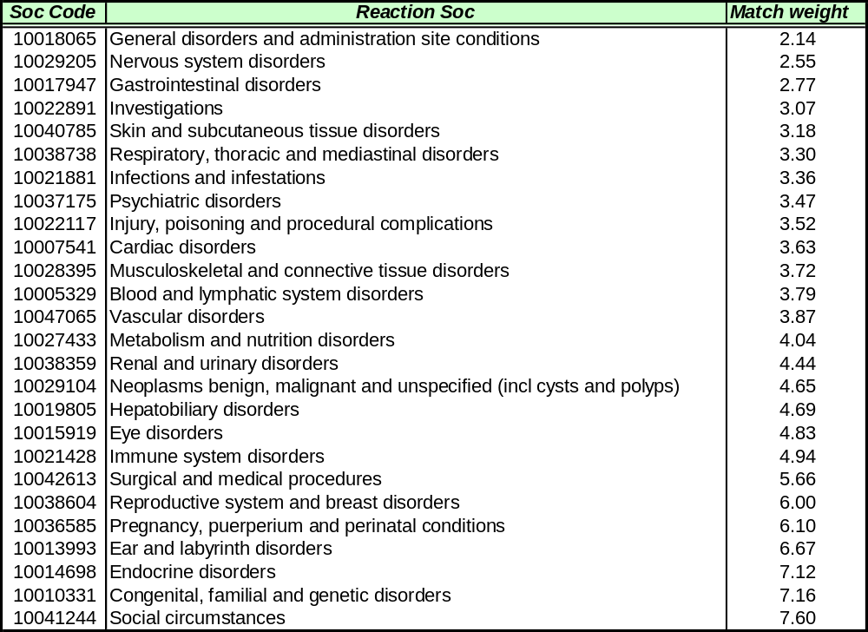

Being a computational improvement that does not impact the algorithm performance in term of precision, this can be provided at a later stage.
Recoded scientific compositions are compared in this version of the algorithm; comparing non-recoded terms did not significantly increase the results, but was at the cost of lower performance, and, since EudraVigilance is undertaking a complete recoding of all the terms reported, in few months there will not be any benefit to compare the reported terms

